As a highly motivated and ambitious computer science student, my objective is to leverage my academic knowledge and passion for technology to contribute to innovative projects and gain practical experience in the field of computer science.

**MATRICULATION**

**METROPOLITAN ACADEMY**

**2012-2020**

BUFFERZONE KARACHI -3 NORTH NAZIMABAD

Karachi ,Pakistan R-543 SECTOR 15/A-3 NORTH NAZIMABAD

Karachi ,Pakistan

+92 3172994491

anussiddiqui543@gmail.com

**EXPERIENCE**

**EDUCATION**

**SKILLS**

**CONTACT**

**OBJECTIVE**

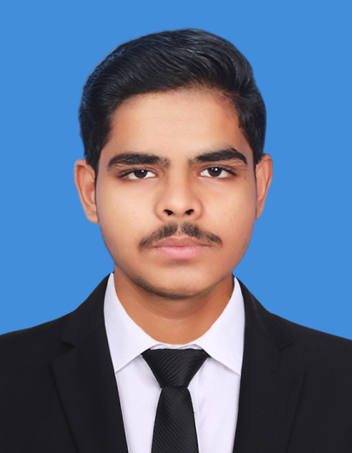

**Muhammad Anus Siddiqui**

**INTERMEDIATE**

**GOVT. COLLEGE FORMEN NAZIMABAD**

**2022-2023**

**BACHELORS IN COMPUTER SCIENCE**

DAWOOD UNIVERSITY OF ENGINEERING

**FIRST YEAR**

391-mail4.png

067-phone.png

001-home.png

* **Six Month working experience as a Front-end Developer in Software House**
* **HTML**
* **CSS**
* **JAVA**